A Minor Project Report

on

|  |  |
| --- | --- |
|  | Description: C:\Users\Staff\Downloads\kr logo.jpg |

**LOAD MANAGEMENT SYSTEM**

**(WIRELESS CONTROLLED DISTRIBUTION TRANSFORMER LOAD MANAGEMENT SYSTEM)**

Degree of

**BACHELOR OF ENGINEERING**

in

**ELECTRONICS AND COMMUNICATION ENGINEERING**

Under the guidance of

**MR. S.ARUNPRATHAP**

**Submitted By**

GANISKA S (927621BEC052)

DHANUSHA R (927621BEC034)

DHIYANESH S (927621BEC048)

BHARATH B (927621BEC026)

**DEPARTMENTOF ELECTRONICS AND COMMUNICATION ENGINEERING**

**M.KUMARASAMY COLLEGE OF ENGINEERING**

(Autonomous)

**KARUR – 639 113**

**M.KUMARASAMY COLLEGE OF ENGINEERING, KARUR**

**BONAFIDE CERTIFICATE**

Certified that this project report **“LOAD MANAGEMENT ”**is the bonafide work of “**GANISKA S (927621BEC052) DHANUSHA R (927621BEC034), DHIYANESH S(927621BEC048), BHARATH B (927621BEC026)** ” who carried out the project work under my supervision in the academic year 2021-2022.

|  |  |  |
| --- | --- | --- |
| **SIGNATURE** |  | **SIGNATURE** |
| Dr.S.Palanivel Rajan, M.E.,Ph.D.,D.Litt (USA).,  **HEAD OF THE DEPARTMENT**  ASSOCIATE PROFESSOR  Department of Electronics and Communication Engineering,  M.Kumarasamy College of Engineering, Thalavapalayam, Karur-639113 |  | Mr.S.ARUNPRATHAP, M.E.  **SUPERVISOR**  **ASSISTANT PROFESSOR**  Department of Electronics and Communication Engineering,  M.Kumarasamy College of Engineering, Thalavapalayam, Karur-639113 |

This project report has been submitted for the **18ECP106L-Minor Project I**  Viva Voce Examination held at M.Kumarasamy College of Engineering, Karur on ____________

**Vision and Mission of the Institute and Department**

**Vision**

To emerge as a leader among the top institutions in the field of technical education.

**Mission**

* Produce smart technocrats with empirical knowledge who can surmount the global challenges.
* Create a diverse, fully-engaged, learner-centric campus environment to provide quality education to the students.
* Maintain mutually beneficial partnerships with our alumni, industry and professional associations.

**Department of Electronics and Communication Engineering**

**Vision**

* To empower the Electronics and Communication Engineering students with Emerging Technologies, Professionalism, Innovative Research and Social Responsibility.

**Mission**

* Attain the academic excellence through innovative teaching learning process, research areas & laboratories and Consultancy projects.
* Inculcate the students in problem solving and lifelong learning ability.
* Provide entrepreneurial skills and leadership qualities.
* Render the technical knowledge and industrial skills of faculties.

**PROGRAM EDUCATIONAL OBJECTIVES (PEO'S)**

* **PEO1:** Graduates will have a successful career in academia or industry associated with electronics and communication engineering.
* **PEO2:** Graduates will provide feasible solutions for the challenging problems through comprehensive research and innovation in the allied areas of electronics and communication engineering.
* **PEO3:** Graduates will contribute to the social needs through lifelong learning, practicing professional ethics and leadership quality

**PROGRAM OUTCOMES(PO'S)**

* **PO1: Engineering knowledge:** Apply the knowledge of mathematics, science, engineering fundamentals, and an engineering specialization to the solution of complex engineering problems
* **PO2: Problem analysis:** Identify, formulate, review research literature, and analyze complex engineering problems reaching substantiated conclusions using first principles of mathematics, natural sciences, and engineering sciences
* **PO3: Design/development of solutions:** Design solutions for complex engineering problems and design system components or processes that meet the specified needs with appropriate consideration for the public health and safety, and the cultural, societal, and environmental considerations
* **PO4: Conduct investigations of complex problems:** Use research-based knowledge and research methods including design of experiments, analysis and interpretation of data, and synthesis of the information to provide valid conclusions
* **PO5: Modern tool usage:** Create, select, and apply appropriate techniques, resources, and modern engineering and IT tools including prediction and modeling to complex engineering activities with an understanding of the limitations
* **PO6: The engineer and society:** Apply reasoning informed by the contextual knowledge to assess societal, health, safety, legal and cultural issues and the consequent responsibilities relevant to the professional engineering practice
* **PO7: Environment and sustainability:**Understand the impact of the professional engineering solutions in societal and environmental contexts, and demonstrate the knowledge of, and need for sustainable development
* **PO8: Ethics :**Apply ethical principles and commit to professional ethics and responsibilities and norms of the engineering practice
* **PO9: Individual and team work:** Function effectively as an individual, and as a member or leader in diverse teams, and in multidisciplinary settings
* **PO10: Communication:** Communicate effectively on complex engineering activities with the engineering community and with society at large, such as, being able to comprehend and write effective reports and design documentation, make effective presentations, and give and receive clear instructions
* **PO11: Project management and finance:** Demonstrate knowledge and understanding of the engineering and management principles and apply these to one’s own work, as a member and leader in a team, to manage projects and in multidisciplinary environments
* **PO12: Life-long learning:** Recognize the need for, and have the preparation and ability to engage in independent and life-long learning in the broadest context of technological change.

**PROGRAM SPECIFIC OUTCOMES(PSO'S)**

* **PSO1**: Applying knowledge in various areas, like Electronics, Communications, Signal processing, VLSI, Embedded systems etc., in the design and implementation of Engineering application.
* **PSO2**: Able to solve complex problems in Electronics and Communication Engineering with analytical and managerial skills either independently or in team using latest hardware and software tools to fulfil the industrialexpectations**.**

**MAPPING OF PROJECT WITH POs AND PSO**

|  |  |
| --- | --- |
| **Abstract**  **Wireless controlled** | **Matching with POs , PSOs**    **POS11 POS8 POS** |

**ABSTRACT:**

The aim of this application is to reduce the manual effort needed to manage transactions in a company. Vehicle Management System has three types of monitoring. Goods loading, goods height and persons in goods garage. Notification will send through wireless network to Users. Application provides an interface to users to view the details like the Trans Vehicle details, goods loading and height of goods, Details in Daily Reports.

**LIST OF FIGURES**

**FIGURE NO FIGURE NAME PAGE NO :**

**1.** Block diagram for load management system 12

**2**. Ardino Nano Features 16

**3.** Ardino Nano Pinout 18

**4.**  Pin diagram for LCD 20

**5** **.** Buzzer module 22

**Abstract**

1. **Introduction**
2. **Objective**
3. **Block diagram**
4. **Metholodogy**
5. **Hardware required**
6. **Project methodology**
7. **Conclusion**
8. **References**

**INTRODUCTION:**

Intelligent Transportation Systems (ITS) is the use of Information Technology (IT), sensors and communications technologies for surface transport applications - though road transport applications vastly predominate. Road and other infrastructure building is expensive and environmentally unfriendly; we can make better use of the civil infrastructure by using a broad range of electronic technologies, making transportation systems safe, e client, reliable and environmentally friendly, without implementing new physical infrastructure. ITS cuts across disciplines such as transportation, engineering, telecommunications, computer science, finance, electronic commerce and automotive manufacturing. Use of wireless/radio mobile communications and satellite positioning systems are particularly important.

**OBJECTIVE:**

The main aim is to monitor the goods loading in commercial goods vehicle. Things to checks are Goods loading, goods height and persons in goods garage area in vehicle

**BLOCK DIAGRAM:**

ARDUINO NANO

CONTROLLER

POWER SUPPLY

LCD DISPLAY

BUZZER

LOAD CELL

IR SENSOR

ADC DRIVER CIRCUIT

ULTRASONIC SENSOR

**METHODOLOGY:**

In this project we are going monitoring the goods using sensors and wireless network. Here we are going monitoring goods loading and height management and person monitor in goods area using sensors node. In this Arduino nano controller is used to control all the sensors. Here load cell used to monitor good load. If the load exit limited means it will alert through buzzer. IR sensor is used to measure the goods height and ultrasonic sensor is used check person movement in goods garage area. and also it will not to start the engine. It will permit once it will reach permitted level for all conditions

**HARDWARD REQURIED**

* Power supply
* Load cell Sensor
* IR Sensor
* ULTRA SONIC Sensor
* LCD display

**SOFTWARE REQUIRED:**

* Arduino IDE
* Embedded C

**HARDWARE DISCRIPION**

**POWER SUPPLY**

The ac voltage, typically 220V rms, is connected to a transformer, which steps that ac voltage down to the level of the desired dc output. A diode rectifier then provides a full-wave rectified voltage that is initially filtered by a simple capacitor filter to produce a dc voltage. This resulting dc voltage usually has some ripple or ac voltage variation.

A regulator circuit removes the ripples and also remains the same dc value even if the input dc voltage varies, or the load connected to the output dc voltage changes. This voltage regulation is usually obtained using one of the popular voltage regulator IC units.

TRANSFORMER

RECTIFIER

FILTER

IC REGULATOR

LOAD

Fig. Block Diagram of Power supply

**Working principle**

**Transformer**

The potential transformer will step down the power supply voltage (0-230V) to (0-6V) level. Then the secondary of the potential transformer will be connected to the precision rectifier, which is constructed with the help of op–amp. The advantages of using precision rectifier are it will give peak voltage output as DC, rest of the circuits will give only RMS output.

**LOAD CELL**

A load cell is a type of transducer, specifically a force transducer. It converts a force such as tension, compression, pressure, or torque into an electrical signal that can be measured and standardized. As the force applied to the load cell increases, the electrical signal changes proportionally. The most common types of load cell used are hydraulic, pneumatic, and strain gauge.

**IR Sensor:**

An [infrared sensor](https://www.elprocus.com/ir-remote-control-basics-operation-application/) is an electronic device that emits in order to sense some aspects of the surroundings. An IR sensor can measure the heat of an object as well as detects the motion. These types of sensors measures only infrared radiation, rather than emitting it that is called as a [passive IR sensor](https://www.elprocus.com/passive-infrared-pir-sensor-with-applications/). Usually in the infrared spectrum, all the objects radiate some form of thermal radiations. These types of radiations are invisible to our eyes that can be detected by an infrared sensor. The emitter is simply an IR LED ([Light Emitting Diode](http://www.elprocus.com/explain-different-types-leds-working-applications-engineering-students/)) and the detector is simply an IR photodiode which is sensitive to IR light of the same wavelength as that emitted by the IR LED. When IR light falls on the photodiode, the resistances and these output voltages, change in proportion to the magnitude of the IR light received.

[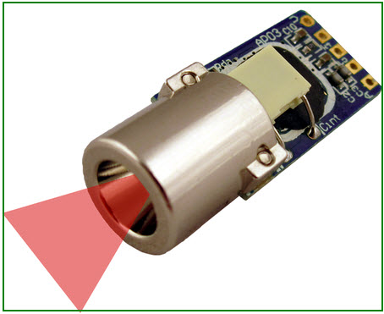](http://www.elprocus.com/wp-content/uploads/2015/01/ir-sensor.jpg)

**ULTRASONIC SENSOR**

**Product features**:

Ultrasonic ranging module HC - SR04 provides 2cm - 400cm non-contact measurement function, the ranging accuracy can reach to 3mm. The modules includes ultrasonic transmitters, receiver and control circuit. The basic principle of work:

* Using IO trigger for at least 10us high level signal,
* The Module automatically sends eight 40 kHz and detect whether there is a pulse signal back.
* IF the signal back, through high level , time of high output IO duration is the time from sending ultrasonic to returning. Test distance = (high level time×velocity of sound (340M/S) / 2,

**Wire connecting direct as following:**

* 5V Supply
* Trigger Pulse Input
* Echo Pulse Output
* 0V Ground

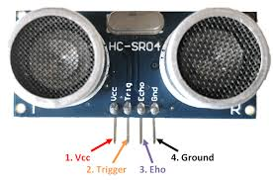

**Attention**

* The module is not suggested to connect directly to electric, if connected electric, the GND terminal should be connected the module first, otherwise, it will affect the normal work of the module.
* When tested objects, the range of area is not less than 0.5 square meters and the plane requests as smooth as possible, otherwise ,it will affect the results of measuring

**Arduino Nano Features**

The features of an Arduino nano mainly include the following.

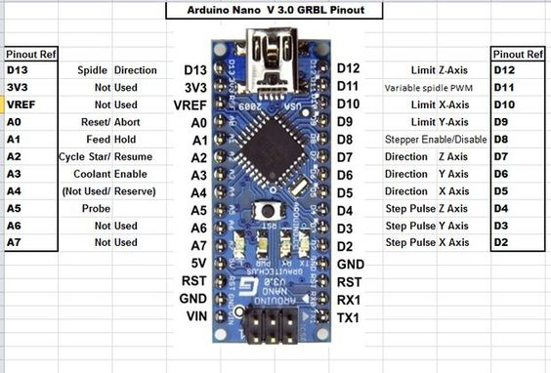

ARDUINO-NANO-BOARD

* ATmega328P Microcontroller is from 8-bit AVR family
* Operating voltage is 5V
* Input voltage (Vin) is 7V to 12V
* Input/Output Pins are 22
* Analog i/p pins are 6 from A0 to A5
* Digital pins are 14
* Power consumption is 19 mA
* I/O pins DC Current is 40 mA
* Flash memory is 32 KB
* SRAM is 2 KB
* EEPROM is 1 KB
* CLK speed is 16 MHz
* Weight-7g
* Size of the printed circuit board is 18 X 45mm
* Supports three communications like SPI, IIC, & USART

**ARDUINO NANO PINOUT**

Arduino nano pin configuration is shown below and each pin functionality is discussed below.

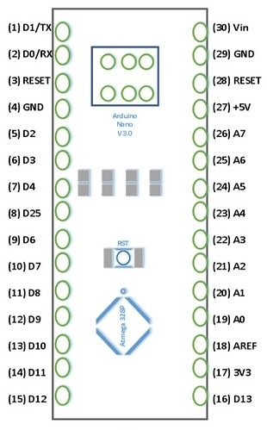

**POWER PIN (VIN, 3.3V, 5V, GND):**

These pins are power pins

* Vin is the input voltage of the board, and it is used when an external [power source](https://www.elprocus.com/what-are-types-of-renewable-energies/) is used from 7V to 12V.
* 5V is the [regulated power supply](https://www.elprocus.com/regulated-power-supply-circuit-working-applications/) voltage of the nano board and it is used to give the supply to the board as well as components.
* 3.3V is the minimum voltage which is generated from the[voltage regulator](https://www.elprocus.com/lm723-voltage-regulator-pin-configuration-circuit-diagram/) on the board.
* GND is the ground pin of the board

**Applications of Arduino Nano**

These boards are used to build Arduino Nano projects by reading inputs of a sensor, a button, or a finger and gives an output by turning motor or LED ON, or and some of the applications are listed below.

* Samples of electronic systems & products
* [Automation](https://www.elprocus.com/home-automation-system-applications/)
* Several [DIY projects](https://www.elprocus.com/diy-project-kits-electrical-electronics-engineering-students/)
* Control Systems
* Embedded Systems
* [Robotics](https://www.elprocus.com/microcontroller-based-robotics-projects-for-engineering-students/)
* Instrumentation

**LIQUID CRYSTAL DISPLAY**

LCD is used to display the results of the system operation such as sensed values, motor status etc….A liquid-crystal display (LCD) is a flat panel display, electronic visual display, or video display that uses the light modulating properties of liquid crystals. Liquid crystals do not emit light directly. The LCD standard requires 3 control lines and 8 I/O lines for the data bus. The most commonly used Character based LCDs are based on Hitachi's HD44780 controller or other which are compatible with HD44580. In this tutorial, we will discuss about character based LCDs, their interfacing with various microcontrollers, various interfaces (8-bit/4-bit), programming, special stuff and tricks you can do with these simple looking LCDs which can give a new look to your application.

**PIN DESCRIPTION**

The most commonly used LCDs found in the market today are 1 Line, 2 Line or 4 Line LCDs which have only 1 controller and support at most of 80 charachers, whereas LCDs supporting more than 80 characters make use of 2 HD44780controllers.

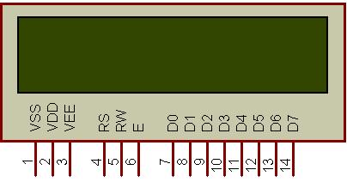

**Figure 1: Character LCD type HD44780 Pin diagram**

Most LCDs with 1 controller has 14 Pins and LCDs with 2 controller has 16 Pins (two pins are extra in both for back-light LED connections).

|  |  |  |
| --- | --- | --- |
| **Pin No.** | **Name** | **Description** |
| Pin no. 1 | **D7** | Data bus line 7 (MSB) |
| Pin no. 2 | **D6** | Data bus line 6 |
| Pin no. 3 | **D5** | Data bus line 5 |
| Pin no. 4 | **D4** | Data bus line 4 |
| Pin no. 5 | **D3** | Data bus line 3 |
| Pin no. 6 | **D2** | Data bus line 2 |
| Pin no. 7 | **D1** | Data bus line 1 |
| Pin no. 8 | **D0** | Data bus line 0 (LSB) |
| Pin no. 9 | **EN1** | Enable signal for row 0 and 1 (1stcontroller) |
| Pin no. 10 | **R/W** | 0 = Write to LCD module 1 = Read from LCD module |
| Pin no. 11 | **RS** | 0 = Instruction input 1 = Data input |
| Pin no. 12 | **VEE** | Contrast adjust |
| Pin no. 13 | **VSS** | Power supply (GND) |
| Pin no. 14 | **VCC** | Power supply (+5V) |
| Pin no. 15 | **EN2** | Enable signal for row 2 and 3 (2ndcontroller) |
| Pin no. 16 | **NC** | Not Connected |

**Instruction Register (IR) and Data Register (DR)**

There are two 8-bit registers in HD44780 controller Instruction and Data register. Instruction register corresponds to the register where you send commands to LCD e.g LCD shift command, LCD clear, LCD address etc. and Data register is used for storing data which is to be displayed on LCD. when send the enable signal of the LCD is asserted, the data on the pins is latched in to the data register and data is then moved automatically to the DDRAM and hence is displayed on the LCD. Data Register is not only used for sending data to DDRAM but also for CGRAM, the address where you want to send the data, is decided by the instruction you send to LCD. We will discuss more on LCD instruction set further in this tutorial.

**BUZZER:**

A buzzer or beeper is a signalling device, usually electronic, typically used in automobiles, household appliances such as a microwave oven, or game shows.

**BUZZER MODULE**



**GENERAL DESCRIPTION:**

A buzzer or beeper is an audio signalling device, which may be mechanical, electromechanical, or piezoelectric. Typical uses of buzzers and beepers include alarm devices, timers and confirmation of user input such as a mouse click or keystroke.

Buzzer is an integrated structure of electronic transducers, DC power supply, widely used in computers, printers, copiers, alarms, electronic toys, automotive electronic equipment, telephones, timers and other electronic products for sound devices. Active buzzer 5V Rated power can be directly connected to a continuous sound, this section dedicated sensor expansion module and the board in combination, can complete a simple circuit design, to "plug and play."

**PIN CONFIGURATION:**

1. VCC

2. Input

3. Ground

**CONCLUSION**

The goods monitoring system provides a proper notification system about the good level (load capacity, load height and persons in load place) in the vehicle and also buzzer is used to alert. The driver can make a false statement about the goods level to the owner and can gain extra money. This scenario can be changed by the notification system. The system helps the owner to have the knowledge of goods level in vehicle and the person of the vehicle load area at regular interval of time. It helps to know the honesty of the driver to the owner and also can save the money. This project goods monitoring system in vehicle represents the notification to the mobile numbers. The proposed goods monitoring system can track the load level in the vehicle and also the alert the information of the vehicle and sends the notification to the owner. This made the project more user-friendly and reliable. The proposed method can be highly beneficial for the automotive industry

**REFERENCES**

1. Albert Alexe, R.Ezhilarasie, “Cloud Computing Based Vehicle Tracking Information Systems”, ISSN : 2229-4333 (Print) ISSN: 0976-8491 (Online) IJCST Vol. 2, Issue 1, March 2011.
2. Anand. T. M, Banupriya. K, M. Deebika, and A. Anusiya, Intelligent Transportation Systems using IoT Service for Vehicular Data Cloud, International Journal for Innovative Research in Science & Technology, Vol.2, No. 02, pp. 80-86, 2015.
3. Hoang Dat Pham; Drieberg, M.; Chi Cuong Nguyen, "Development of vehicle tracking system using GPS and GSM modem," Open Systems (ICOS), 2013 IEEE Conference on, vol., no., pp.89,94, 2-4 Dec. 2013.
4. Jaun Zambada, Ricardo Quintero, Ramon Isijara, Ricardo Galeana, Luis Santillan, “An IoT based scholar bus monitoring system”, IEEE 2015.
5. Jyothi kiran. M, Ravi teja. S. Vehicle Health Monitoring Systems.. International Journal of Engineering Research and Applications Vol. 2, Issue 5, September-October 2012, pp.1162-1167.
6. Lee. S, G. Tewolde and J. Kwon, "Design and implementation of vehicle tracking system using GPS/GSM/GPRS technology and smartphone application,"2014 IEEE World Forum on Internet of Things (WF-IoT), Seoul, 2014.